Java 8 Homework

1. Short answer
   1. Name the differences between imperative and functional programming

Imperative programming is the “how” style of programming whereas functional programming is “what” style of programming. In Imperative we describe each step of action that need to be done to complete the task but in functional Programming, we describe what needs to be done. We use interfaces provided by the system to achieve our task, our main intention is getting the task done, without much bothering about how it is done in each step.

* 1. Explain the meaning of declarative programming. Give an example.

Declarative programming is what style of programming the emphasis is on what needs to be done, and data. It expresses the logic of a computation without describing its control flow.

For example: SQL

* 1. Name the benefits of including functional style programming in Java

Function style programming codes are smaller than compared to others, the code is more concise and code readability is also better. Another benefit is concurrency

**Level 3 begins here :**

4) Use DoubleSummaryStatistics to output to the console the top test score, lowest test score, and average among all test scores in a given list.

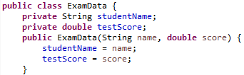

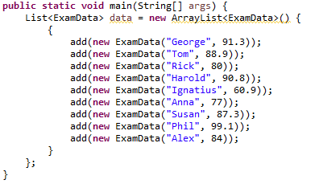

--------------------------------------------------------------------------------------------------------------

5) Redo the first lab you had, the School lab, using Java 8 streams and lambda expressions.

Do one level at a time.

6) Redo Labs 3, 3.1, and 3.2 using Java 8 streams and lambda expressions.

7) Level 3 : Study ‘Program 4’ of the file I gave you, of complete Java 8 programs.

Understand All of the code. Look at the ‘**// group Employees by department’**

**// collect(Collectors.groupingBy**

code at the bottom, and understand what it is doing so that you can explain it to me or to

another student. Run the code. Then try to do the following :

a) Print out each department and the average salary for the department.

b) Print out each department and the maximum salary for the department.

c) Print out each department and all of the employees who work at that department.

**************************************************************************

**Extra Credit 1** : Look at (from the Oracle Java API) some of the methods in the Stream interface and the Collectors class, that we have Not covered in class. Understand what they do. Then use them in a real Java program, and make sure your results are correct. Upload these java files to Sakai.

**Extra Credit 2** : Take some, or many of the Stream methods, like filter, map, etc.,

and write your own version of these methods.

For example, write, ‘myFilter’, ‘myMap’ etc.

Test your new methods thoroughly!